**RISE OVERSEAS EDUCATION CONSULTANCY**

**Media Links:**

[https://riseoverseas.in](https://riseoverseas.in/)

<http://www.riseoverseas.in/wp-content/uploads/2019/01/RISE-Overseas-Education-Consultany-Brochure.pdf>

<https://www.instagram.com/riseoverseasedu/?hl=en>

<https://www.facebook.com/RISEOverseasEducationConsultancy/>

<http://www.riseoverseas.in/how-studying-abroad-will-change-your-life-for-good/>

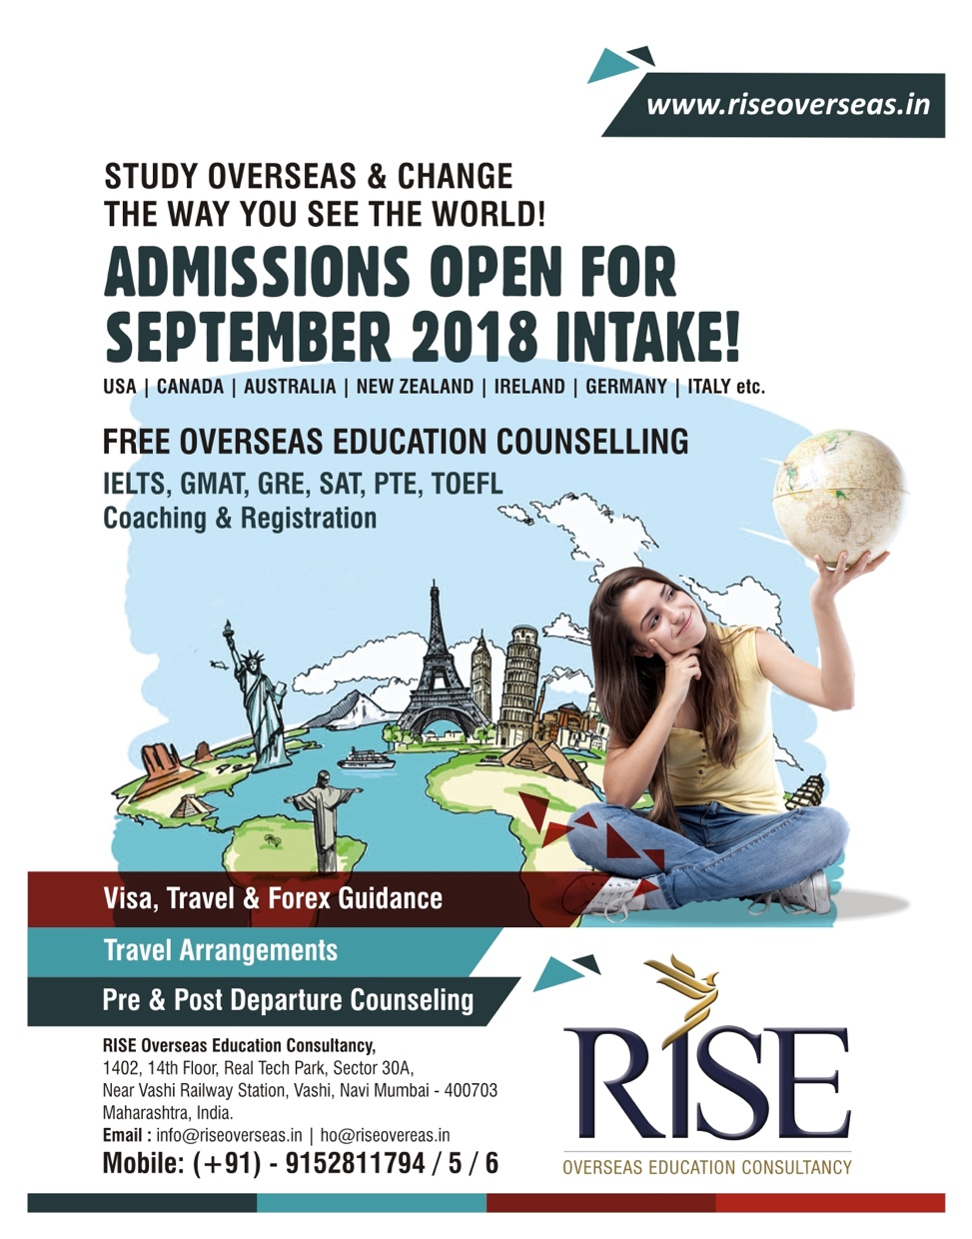

**SOCIAL MEDIA POSTS [COPY & DESIGN]**

